ASSIGNMENT- 1.3
Task Description#1
● Install and configure GitHub Copilot in VS Code. Take screenshots of each step.
Expected Output#1
● Install and configure GitHub Copilot in VS Code. Take screenshots of each step.

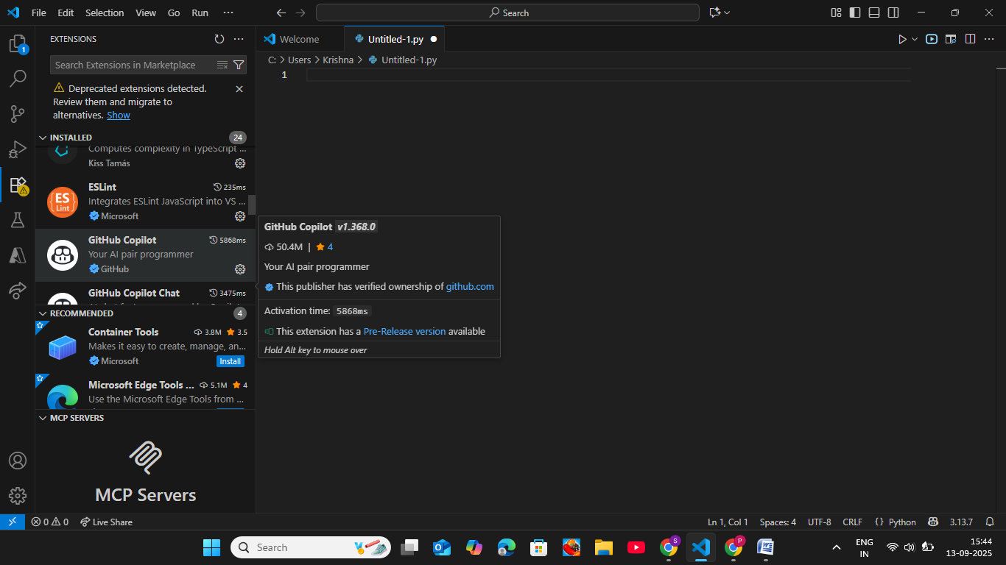

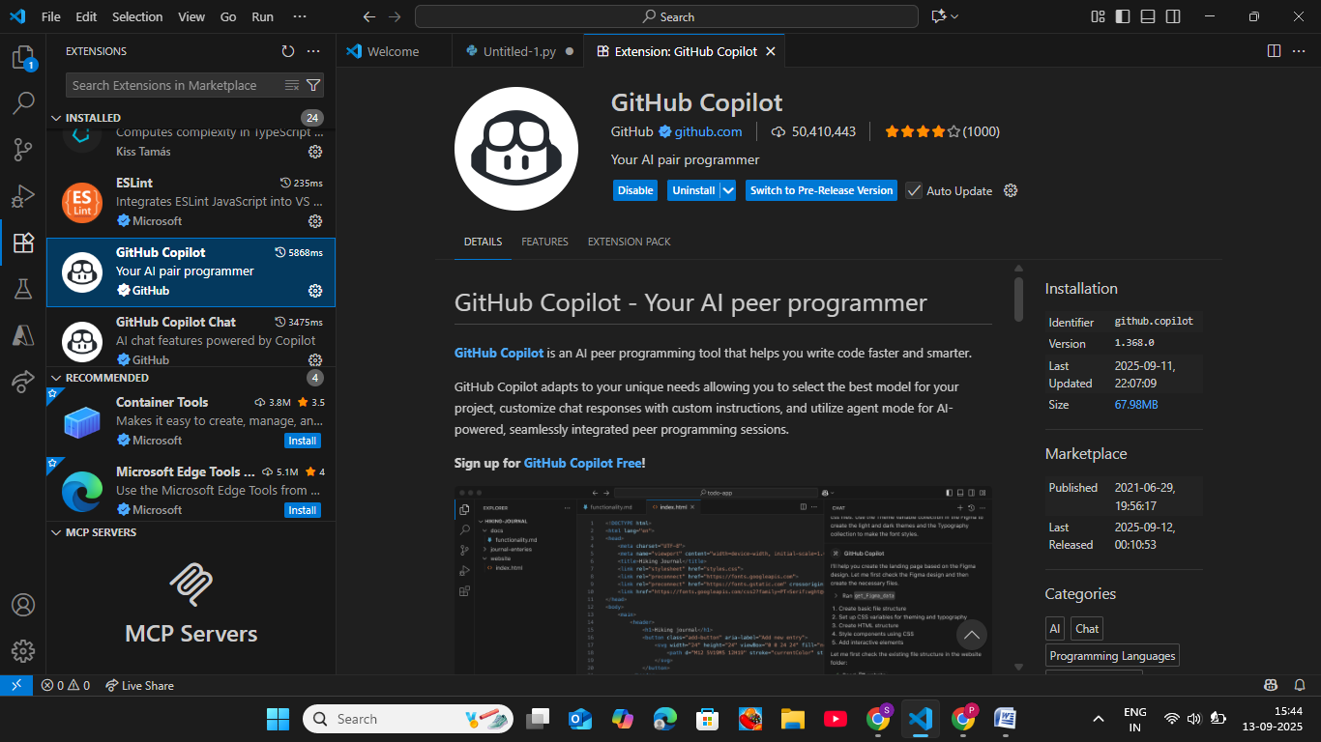

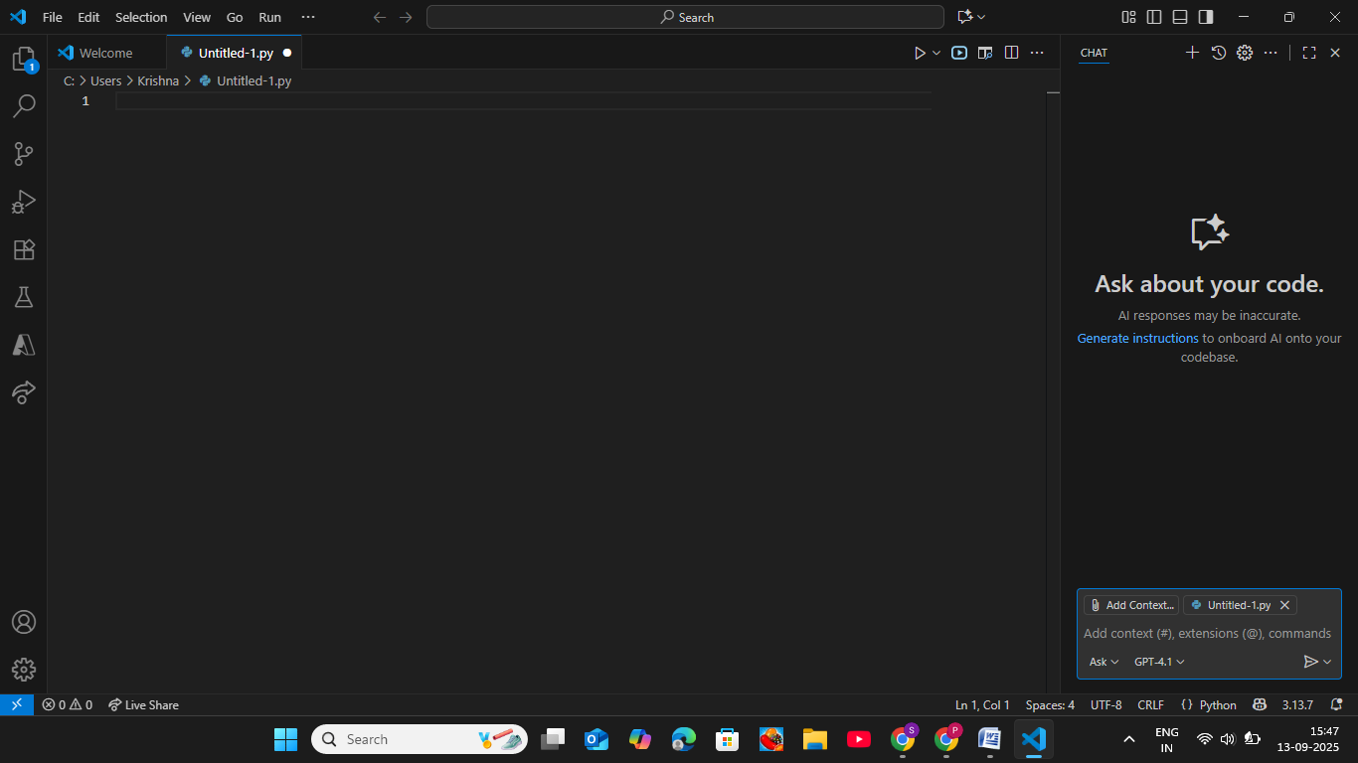

Task Description#2
● Use Copilot to generate a is_prime() Python function.
Expected Output#2
● Function to check primality with correct logic.

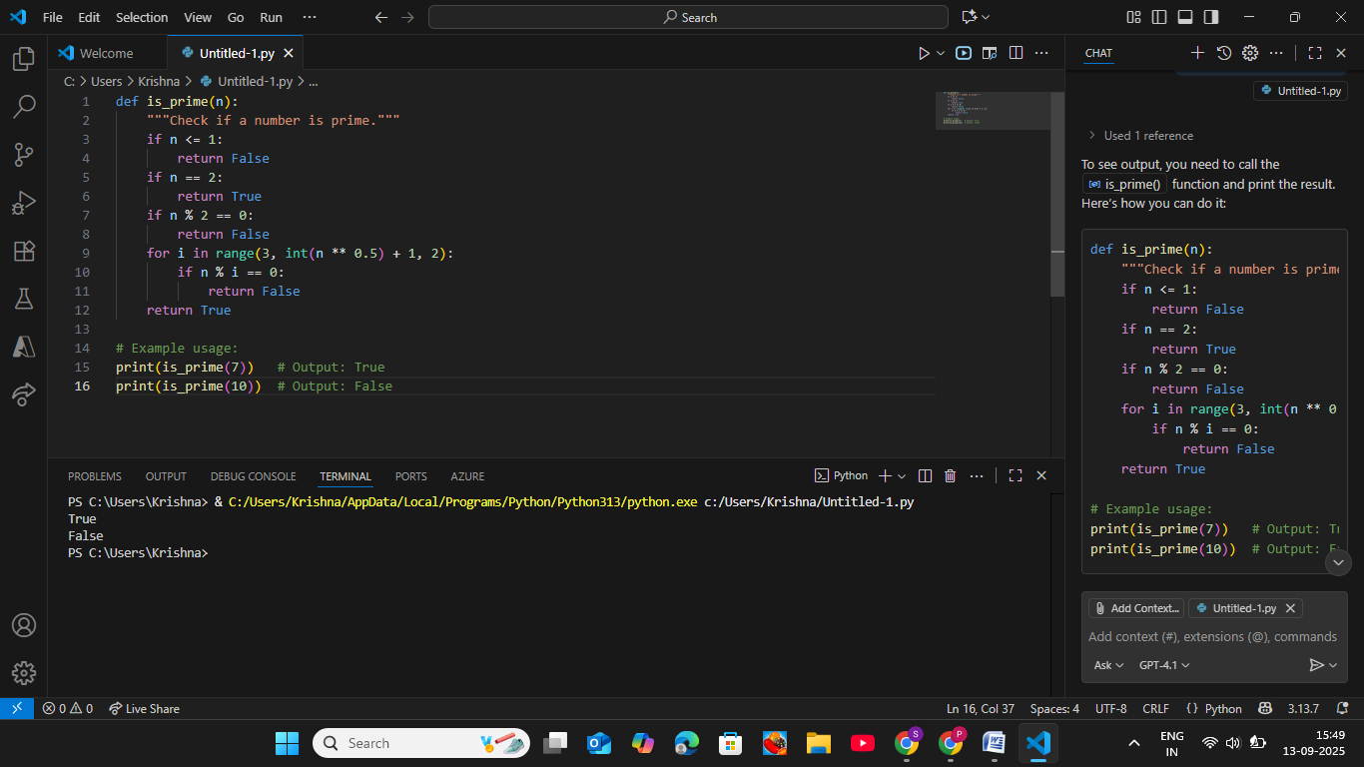

Task Description#3
● Write a comment like # Function to reverse a string and use Copilot to generate the
function.
Expected Output#3
● Auto-completed reverse function

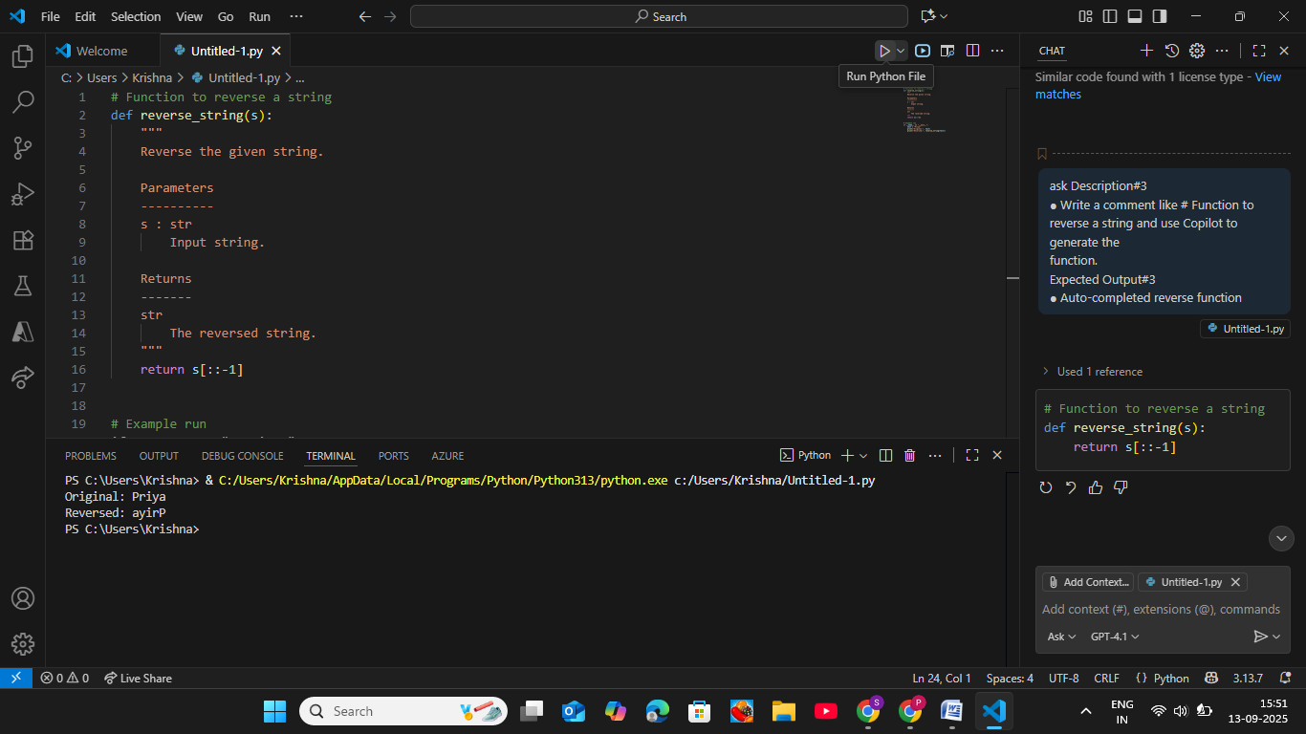

Task Description#4
● Generate both recursive and iterative versions of a factorial function using comments..
Expected Output#4
● Two working factorial implementations.

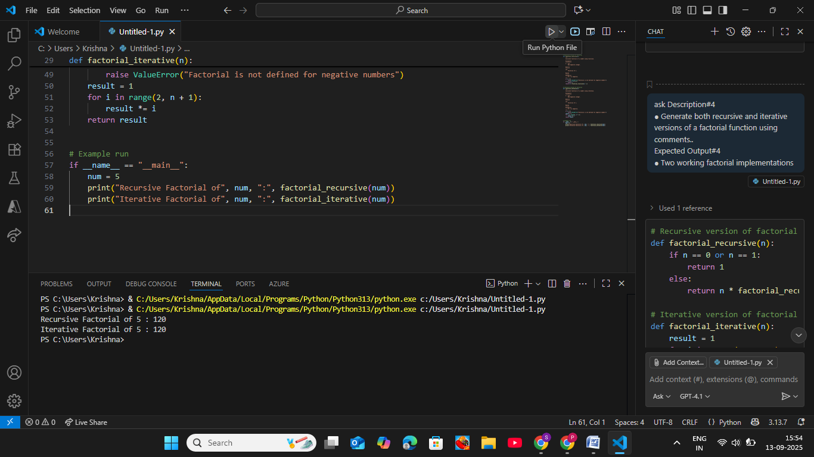

Task Description#5
● Use Copilot to find the largest number in a list. Assess code quality and efficiency.
Expected Output#5
● A valid function with your review.

